# Project Name:Chat Messengar

Developed By:Md.Masud Rana

ID: 1505093

Group:CSE-B2

1.I have used Networking for this project. In this purpose,I have to use several classes,they are:SERVER , Client,Readserver,NetworkConnection etc.I have used TCP connection for this project.I have to use Hashmap,so that I can recognize each of the clients chatting on the messenger.In the hashmap client name is the key & networkconnection is the value.To read the server I have to use readserver class.In this class I splited the entire msg into two parts,in which first part was the clients name.Again,to maintain everything I have used javafx in this project.For several buttons I have to call the classes used in this project in setonaction field etc.

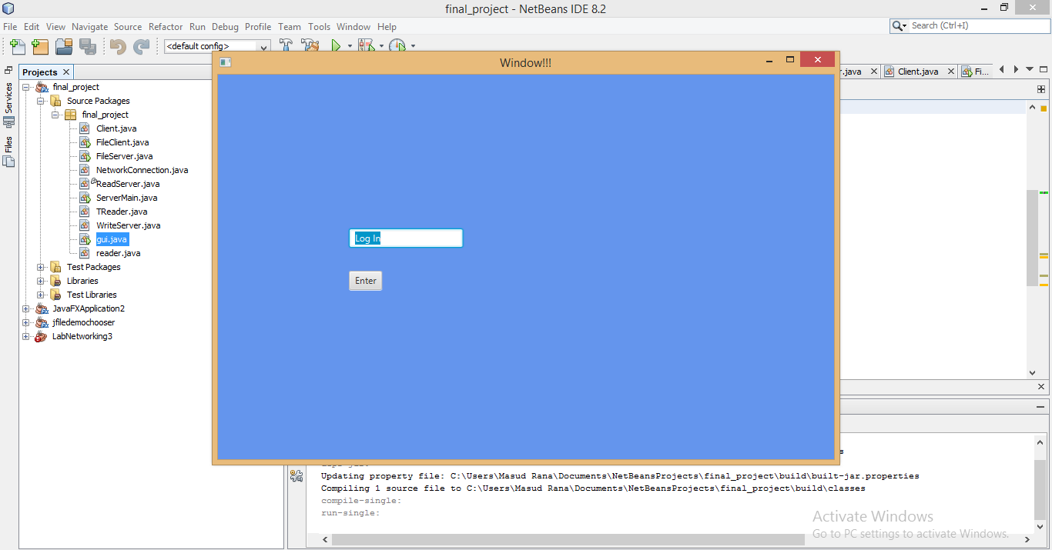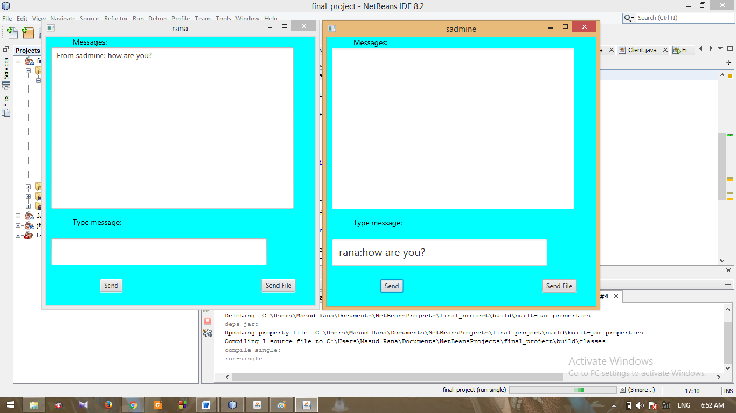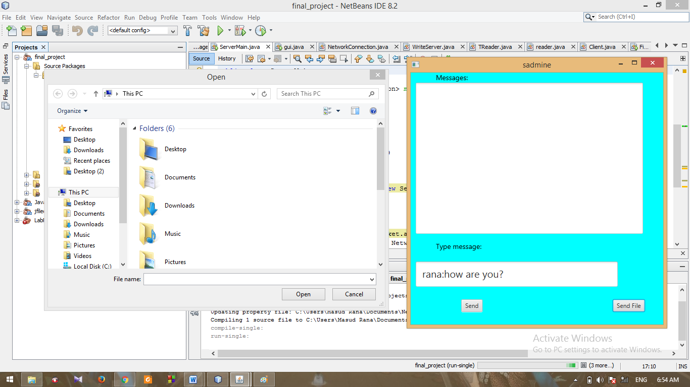

In this project,I could not complete the job of the sending file.I have done 50% of the file sending.I had idea how to send file but I was in trouble while I was working on sending file it was continuously giving me null pointer exception & I couldn’t find the bug anymore ☹ . Ok for sending file (actually text file) I would convert the file into a string.so the rest job was easy like sending msg in the messenger .so,when other client receives the file then I will again convert this string msg into file . I would keep a button in the scene named “receive file”in which,if I press it it will automatically convert the string into file & receive it ☺ . I was stuck in this problem about 4/5 days ☹ . Tried with stack overflow’s code , but it didn’t work anymore .

In addition,I have used FileChooser for handling file.Morever,javafx helped me a lot for increasing the beauty of the project :P .

Thanx “Tonmoy” sir for guiding me & fixing the bug of the project ☺ .